The process i used in building the project

Hey guys here is the detailed series of steps I went through in building the project . Keep in mind thou its just one way among thousands of doing it , so don’t it doenst matter whether we have the same exact code as long as it works . So have fun and happy codding .

The backend

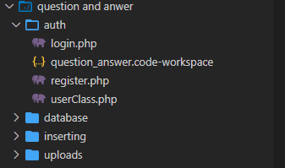

The first thing i thoug of was my folder structure . as show in the image above . the code is seperated in folders for every particular task .

The authentication process

After structuring how our data for use will look like we structered our database as follows

Questions I asked my self

Note : (keep im mind this are just my thoughts not guildlines you should always follow but understand the process of breaking down a task and solving them one by one )

-The first question I asked myself is how do you get to receive data from my react front end to php .

What I found was that the traditional way of using the super global $_POST[‘’] wasn’t going to work

Cause the data i was receiving was stored in an object . and that I instead had to do it this way

$req = json_decode( file_get_contents('php://input') );

after some google that’s what I found . now I could easil receive data from any react frontend and I stored it in my variable I called req which means request.

-The next problem now was how do I accessed the information stored inside an object in php .

Note : php is object oriented . so that was my next search on google

 $name = $req->name;  //extracting the inputs values from the req object

Note : the above is the same as saying in javascript

req.name;

Note : am using name there because I know am receiving a name from my form in the attribute name of my inputs

<input type="text" name="name" onChange={handleChange} />